# Research into Diabetes type 2 current games (Studio Practice)

## Potential Target Audience/ Research:

Young audience like to think with games they can look into the distant future, perhaps feel what they might be like when they are older. Using AR depending on the target audience we can make the game theme relatable. Such as a young audience the theme could be more futuristic/ unrealistic and a more mature audience prefer reality/ realistic themes.

Look into **Svein-Gunnar Johansen** work towards diabetes games for young people

Look into the **The CADMOS project** which is a research project towards diabetes for children being undertaken in Norway

## Ideas that can be used:

1. At the beginning of the game we can have a simple introduction type slide explaining the basics of the situation and the main goal to win. This screen comes up when the user opens the app for the first time and then has the option to remove it/ never see again.

## Current games relating to diabetes:

### The Diabetic Dog:

This is a game where the players have to look after a diabetic dog and keep it alive. The players first start on a screen where they have two options. They are they would like to take care of the dog and they already do, this to me implies a difficulty level. Then it gives the player the option to name his/her dog. Players are also given an option for a manual on how to treat diabetes before they start playing. The players hen have to look after the dog such as walking and feeding while keeping its blood sugar label stable, this is showed with a health bar type thing. Players can see descriptions of the foods/drink they are feeding the dog too. Gameplay is shown below with the link (4)

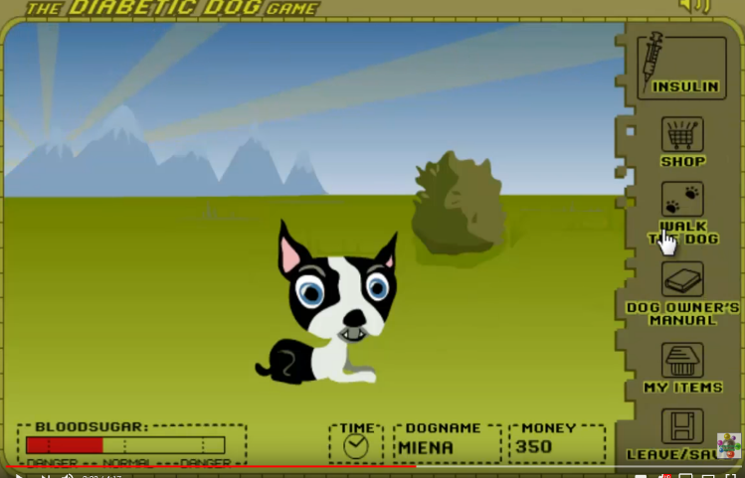

### mySugr App:

This nutrition/ diabetes app where people can log in there eating and exercise habits on a daily basis. The idea of the app is to allow you to create daily entries such as meals you eat and the medication you take etc and have monthly reviews on your progress. It allows you to discover what your estimated HbA1c (Hemoglobin) at any time using the app. It also allows you to view your reports and on different platforms such as Excel and PDF.

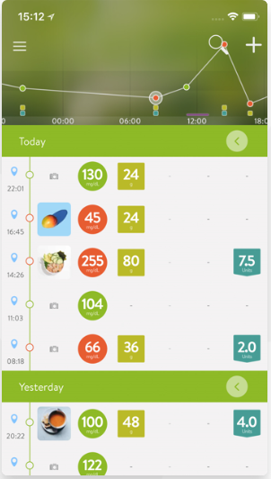

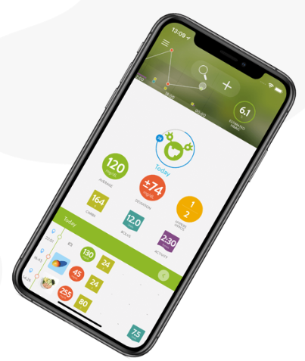

Above is the layout of the app where the users can personalise the layout making it feel unique to them. Users can take photos of what they have had (Our AR element) and the app calculates the nutrition of that food item/meal. The app also gives the user challenges to try and achieve going by the previous entries.

#### Carb Counting with Lenny:

Carb counting with Lenny is a basic carb counting game where the player has to guess if a product it selects has carbs and if it does how much is has. The player is rewarded with points depending on their choices. After a certain amount of products have popped up the player gets the final score with a character appreciation action depending on how well they did by Lenny. The player can then play again if they wish or exit the game. Photos are shown below

#### 

# References

1. <https://partner.sciencenorway.no/technology-e-health-research-forskningno/computer-games-could-help-children-cope-with-diabetes/1459845>
2. <http://www.igf.com/diabetic-dog-game>
3. <http://www.ep.liu.se/ecp/151/002/ecp18151002.pdf>
4. <https://www.youtube.com/watch?v=G69gCO27uKI>
5. <https://timesulin.com/3-diabetes-games-that-will-educate-kids-about-diabetes/>
6. <https://mysugr.com/en/diabetes-app>
7. <http://www.lenny-diabetes.com/games-n-apps.html>
8. <https://ayogo.com/blog/monster-manor/>
9. <http://www.lenny-diabetes.com/carb-counting-with-lenny.html>